LAB 4 TASKS :
BAZIL – UDDIN – KHAN 24K-0559
BSCS-3H

Q1). OUTPUT:
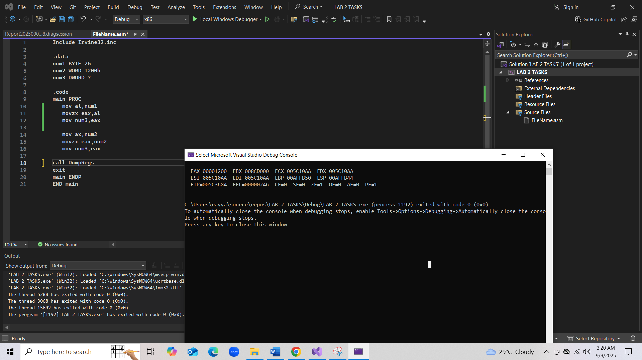
Q1 CODE:
Include Irvine32.inc

.data
num1 BYTE 25
num2 WORD 1200h
num3 DWORD ?

.code
main PROC
mov al,num1
movzx eax,al
mov num3,eax

mov ax,num2
movzx eax,num2
mov num3,eax

call DumpRegs
exit
main ENDP
END main

Q2).OUTPUT:
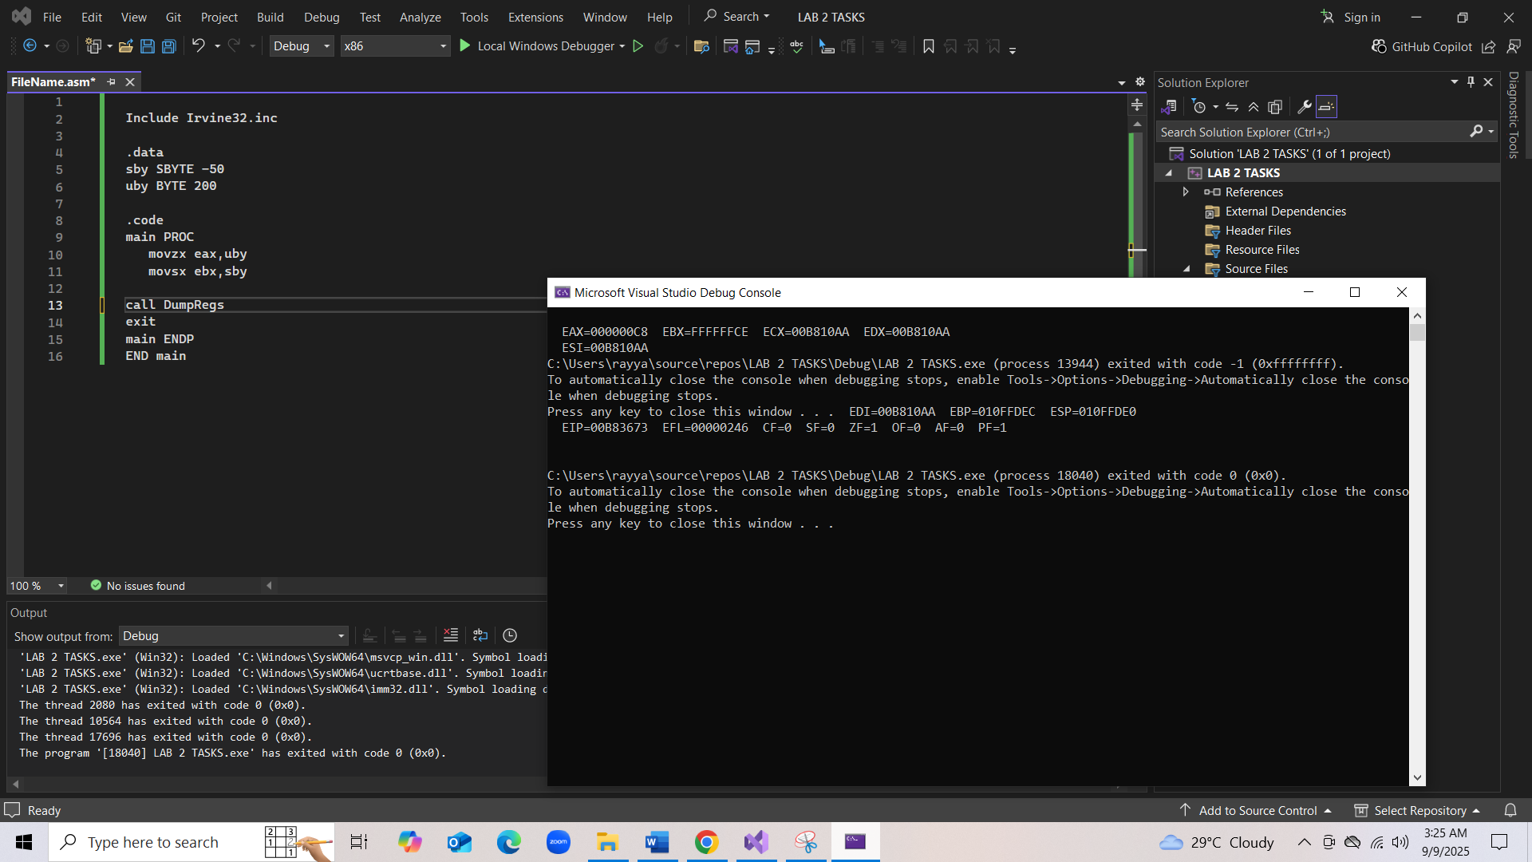

Q2 CODE:
Include Irvine32.inc

.data
sby SBYTE -50
uby BYTE 200
.code
main PROC
movzx eax,uby
movsx ebx,sby
call DumpRegs
exit
main ENDP
END main
Q3). OUTPUT:
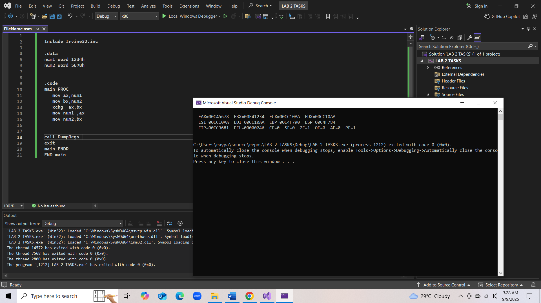

Q3 CODE:

Include Irvine32.inc

.data
num1 word 1234h
num2 word 5678h

.code
main PROC
mov ax,num1
mov bx,num2
xchg ax,bx
mov num1 ,ax
mov num2,bx

call DumpRegs
exit
main ENDP
END main

Q4). OUTPUT:
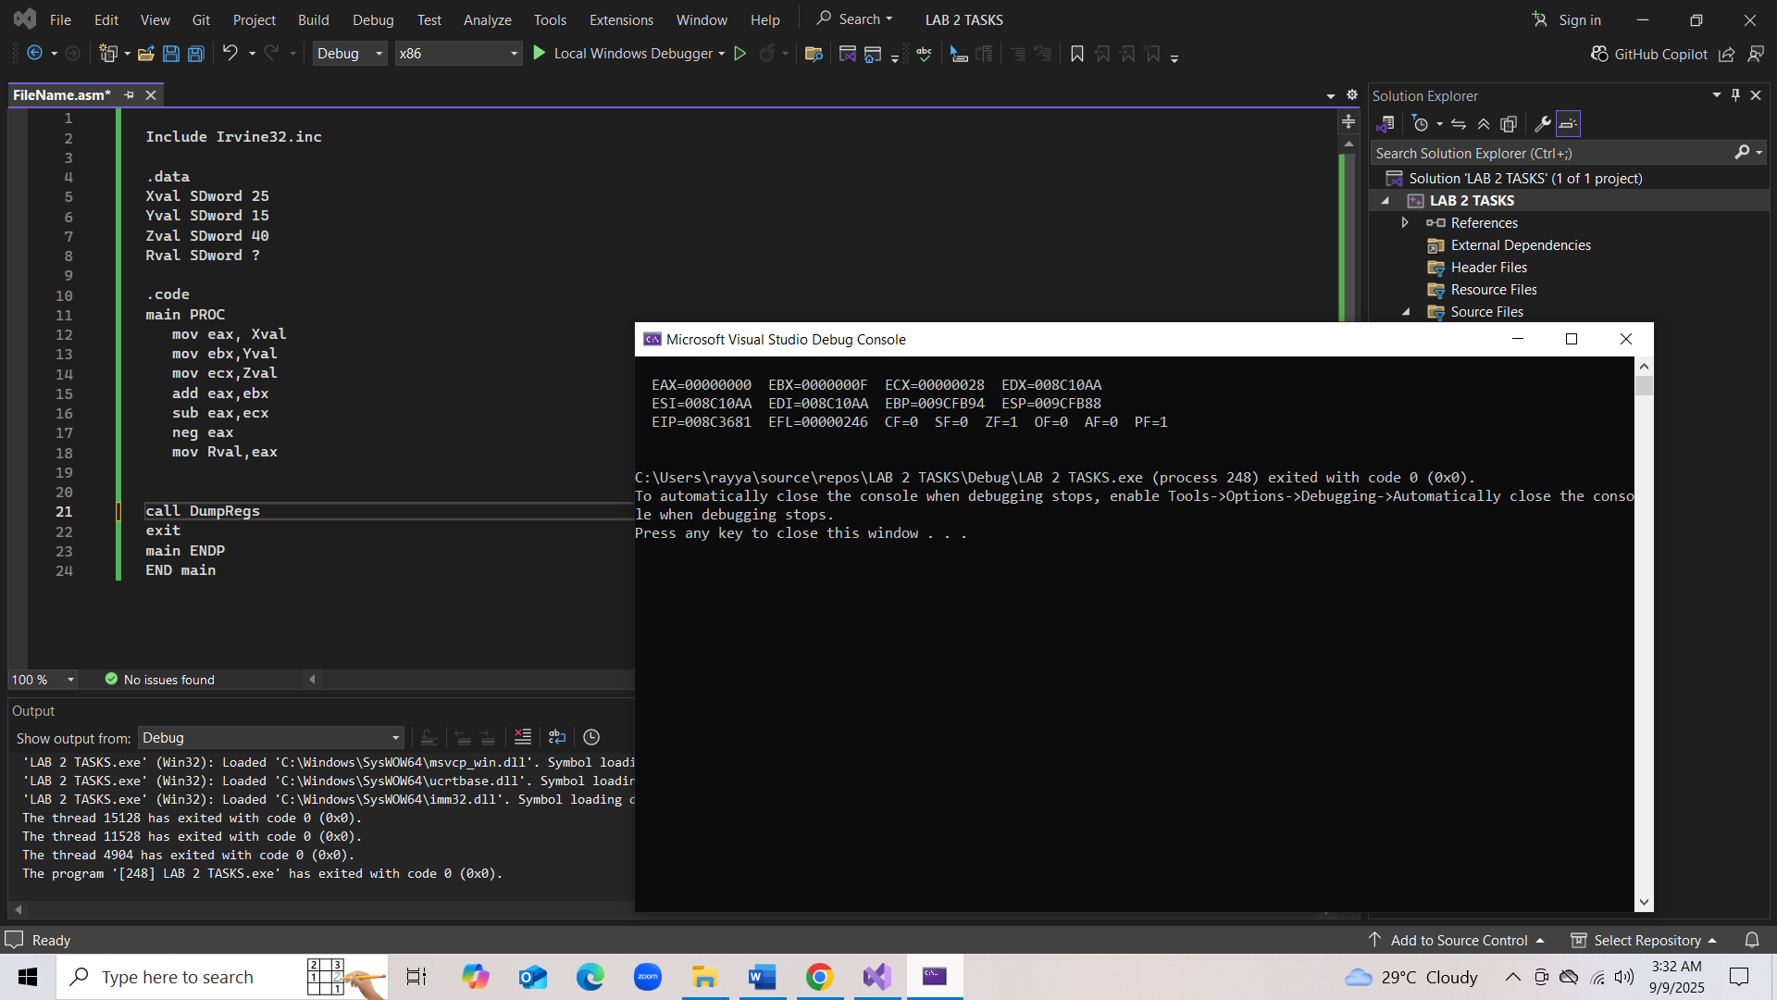
Q4 CODE:
Include Irvine32.inc

.data
Xval SDword 25
Yval SDword 15
Zval SDword 40
Rval SDword ?

.code
main PROC
mov eax, Xval
mov ebx,Yval
mov ecx,Zval
add eax,ebx
sub eax,ecx
neg eax
mov Rval,eax

call DumpRegs
exit
main ENDP
END main

Q5). OUTPUT:
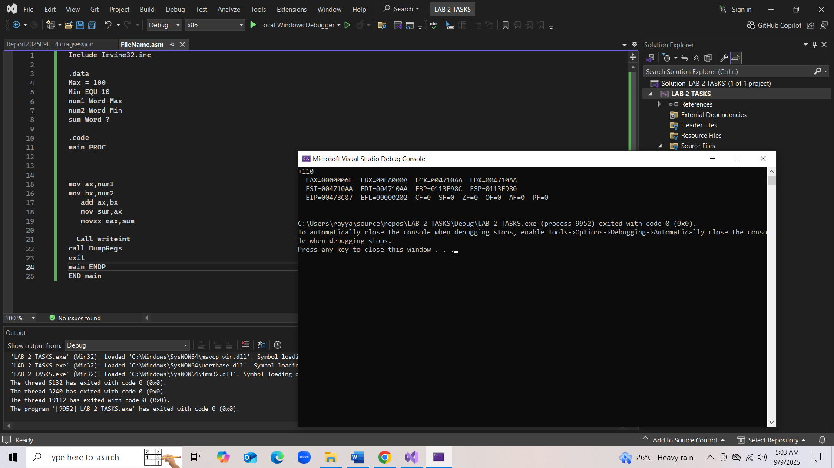

Q5 CODE:
Include Irvine32.inc

.data
Max = 100
Min EQU 10
num1 Word Max
num2 Word Min
sum Word ?

.code
main PROC

mov ax,num1
mov bx,num2
add ax,bx
mov sum,ax
movzx eax,sum

Call writeint
call DumpRegs
exit
main ENDP
END main

